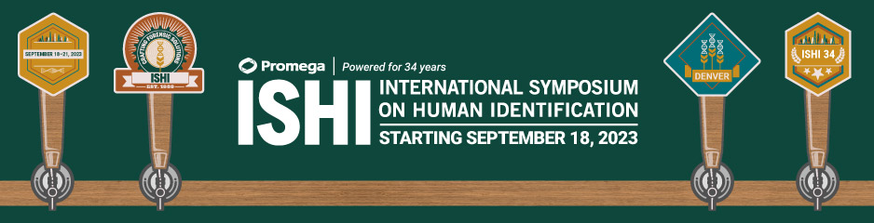
Budget Item | Estimated Cost
Airfare to Denver International Airport
Transportation  (From airport to Hyatt Regency) | Denver Airport Rail ~$10.50 each way
Hotel  (Rates can be found here) | $269 + taxes/night for standard room  *A limited number of government rooms are available
Meals
(Breakfast Tuesday – Thursday, lunch Tuesday and Wednesday, and dinner Wednesday included)
Off-Site Event  (Wednesday evening event) | FREE
Symposium Registration (In-Person)  (Cancelation fees waived for 2021) | $495 for students  $795 before July 31st  $895 after July 31st
Workshops
(Options and costs available on our website)
Miscellaneous Expenses

TOTAL

